PROJECT-1
NAME: Daggubati HarshaDeep
EMAIL:harshadeep185@gmail.com
MOBILE NO:9494995336
BATCH NO: B-114,4PM
COURSE:AWS,DEVOPS
TRAINER NAME:V.MADHUKAR REDDY
Project: Deploying a application into different environments

Pipeline Script
pipeline{
agent any
parameters{
choice(
choices:['YES','NO'],
description:'deploy to tomcat?',
name:'DEPLOY'
)
}
stages{
stage('clone'){
steps{
git branch: 'dev', credentialsId: 'tomcat', url: 'https://github.com/harshadeep185/taxi-booking.git'
}
}
stage('validate'){
steps{
sh 'mvn validate'
}
}
stage('compile'){
steps{
sh 'mvn compile'
}
}
stage('test'){
steps{
sh 'mvn test'
}
}
stage('package'){
steps{
sh 'mvn package'
}
}
stage('deploy to dev'){
when{
expression{
params.DEPLOY=='YES'
}
}
steps{
input "do you want to deploy to dev env"
deploy adapters: [tomcat9(credentialsId: 'tomcat1', path: '', url: 'http://3.90.110.91:8080')], contextPath: null, war: '**/*.war'
}
}
stage('deploy to test'){
when{
expression{
params.DEPLOY=='YES'
}
}
steps{
input "do you want to deploy to test env"
deploy adapters: [tomcat9(credentialsId: 'tomcat1', path: '', url: 'http://3.90.10.48:8080')], contextPath: null, war: '**/*.war'
}
}
stage('deploy to prod'){
when{
expression{
params.DEPLOY=='YES'
}
}
steps{
input "do you want to deploy to prod env"
deploy adapters: [tomcat9(credentialsId: 'tomcat1', path: '', url: 'http://54.227.59.146:8080')], contextPath: null, war: '**/*.war'
}
}
stage('deploy to pre-prod'){
when{
expression{
params.DEPLOY=='YES'
}
}
steps{
input "do you want to deploy to pre-prod env"
deploy adapters: [tomcat9(credentialsId: 'tomcat1', path: '', url: 'http://34.239.142.32:8080')], contextPath: null, war: '**/*.war'
}
}
}
}
->First we creat tomcat instance

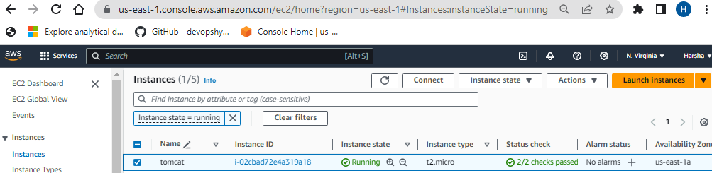

-> We want creat AMI by useing existing tomcat to creat 3 more tomcat servers

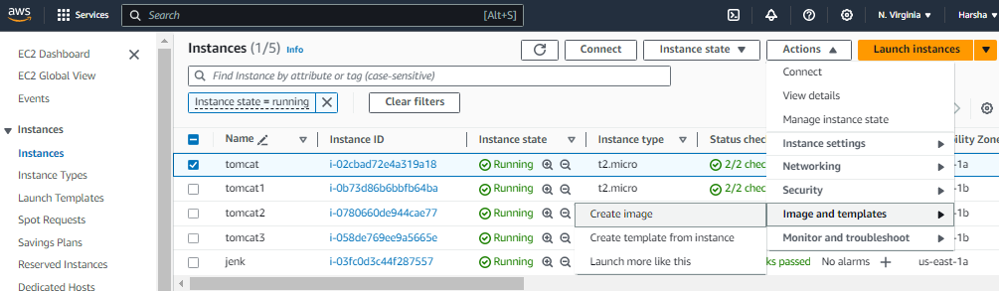

-> Then AMI will created in Images
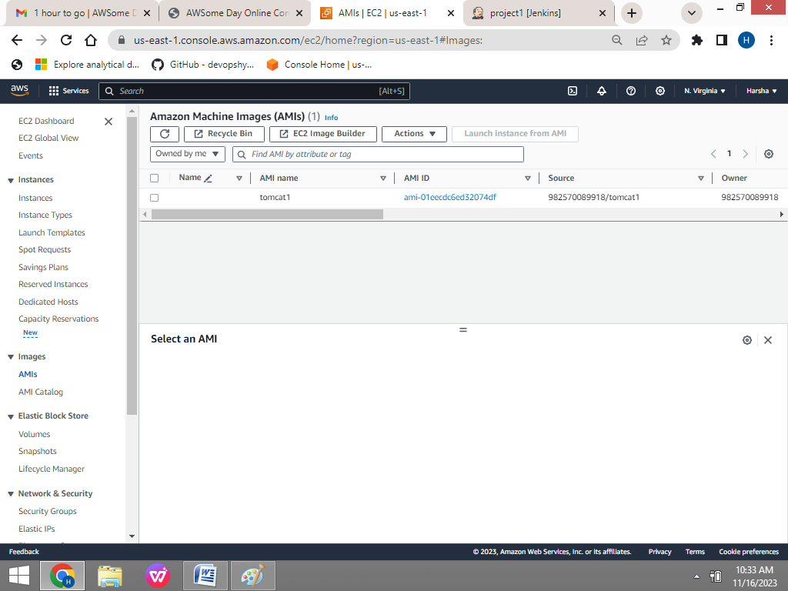

-> Then select AMI and click on launch instance from AMI

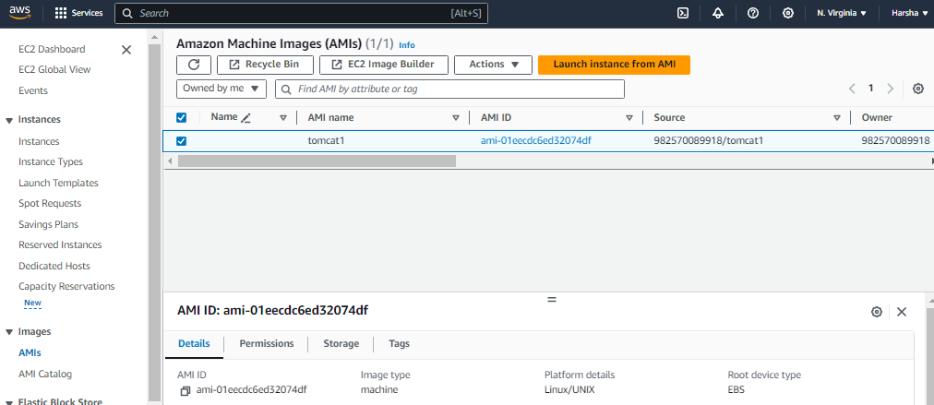

-> We want give name and right side we want give number of Instances want to be created

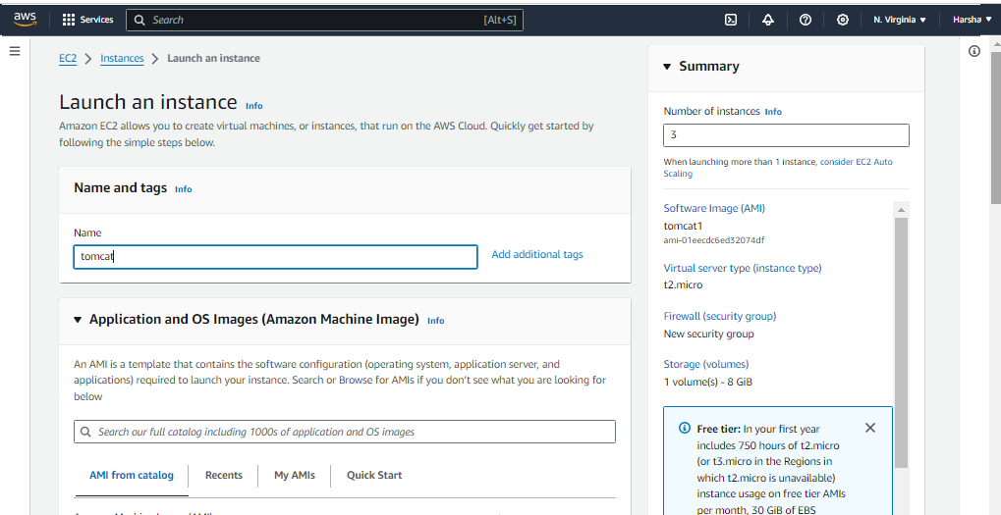
-> At down we want select MY AMIS and click on Shared with me and select the AMI then launch instance

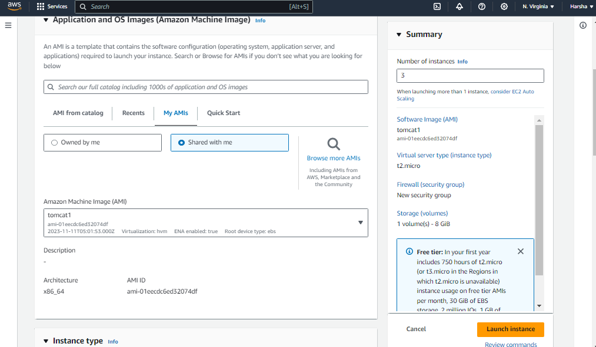
-> Then the tomcat instances created
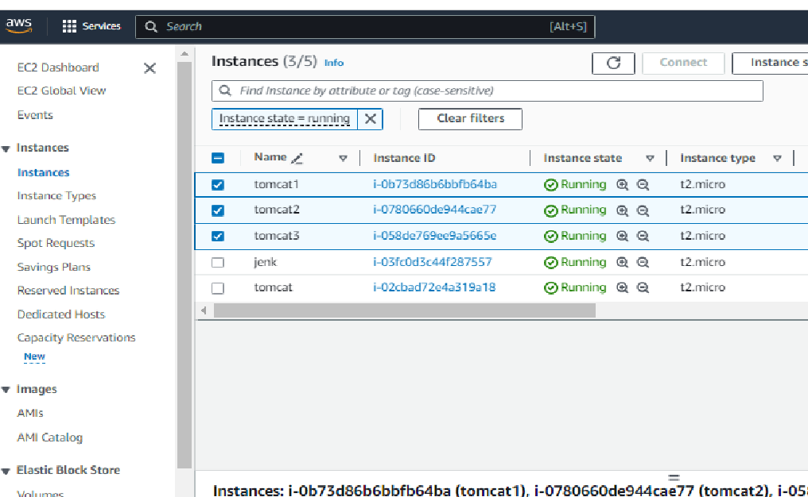

-> Now open Jenkins
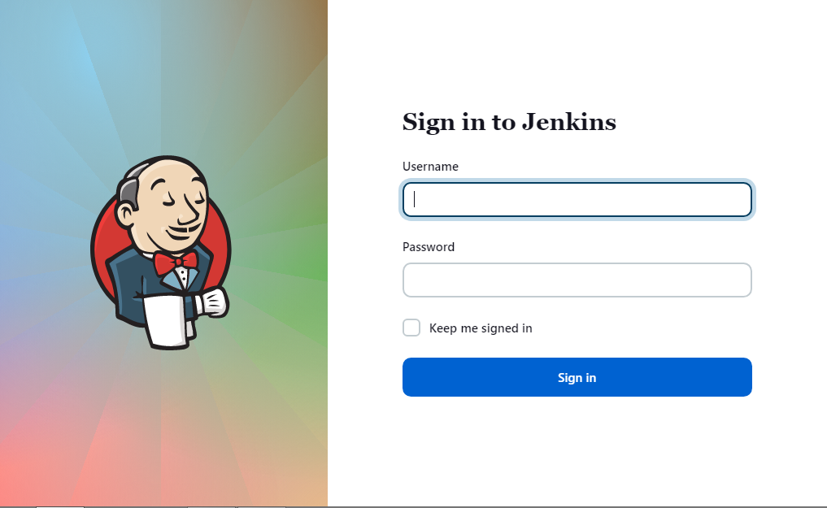
-> Creat the new Pipeline
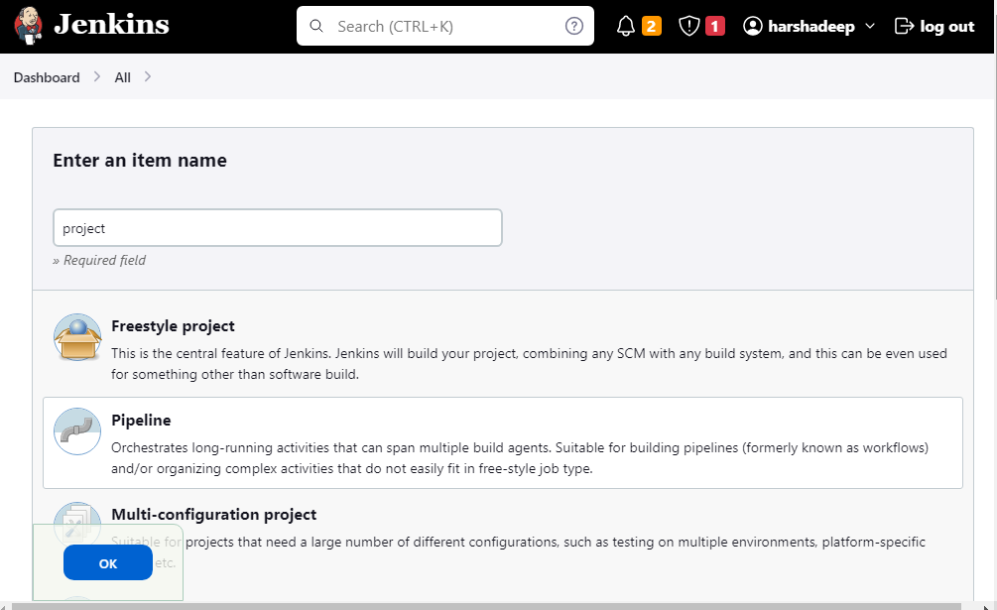
-> We want to write the script in pipeline
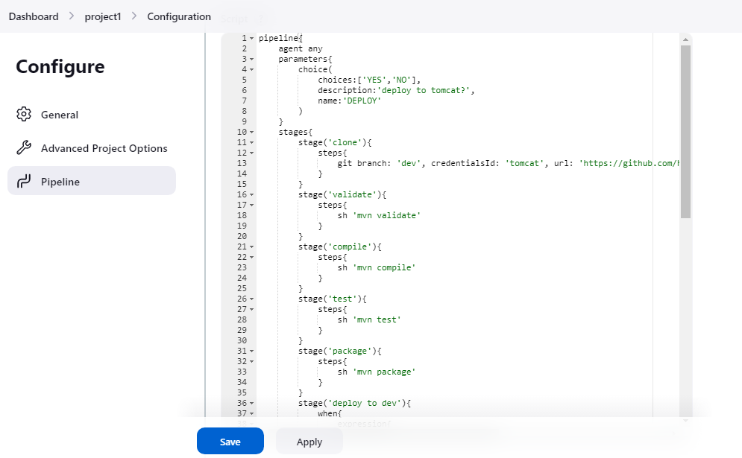

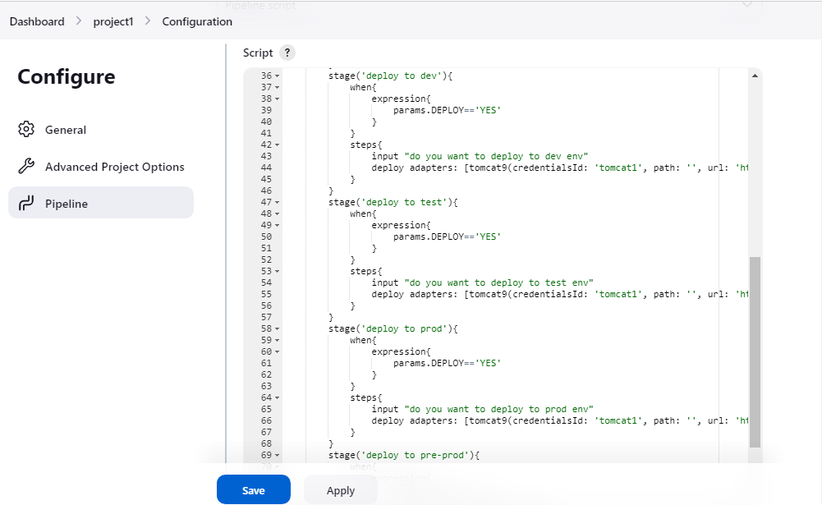
->After writing script we want apply and save it and Build with parameters
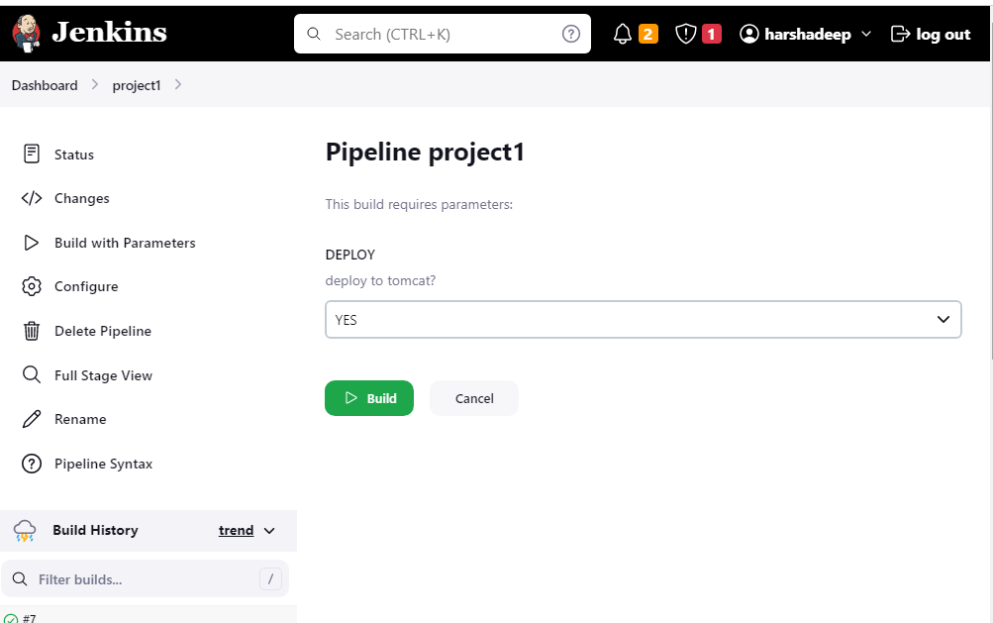

-> It will ask the permission for deploying to tomcat Proceed or Abort

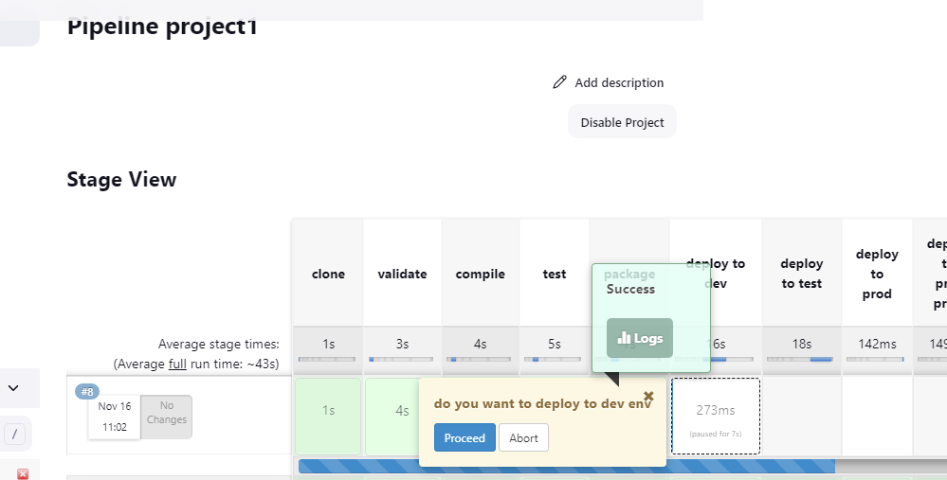

->After that deployment will be successfully
->First opening the tomcat we want give the id and password
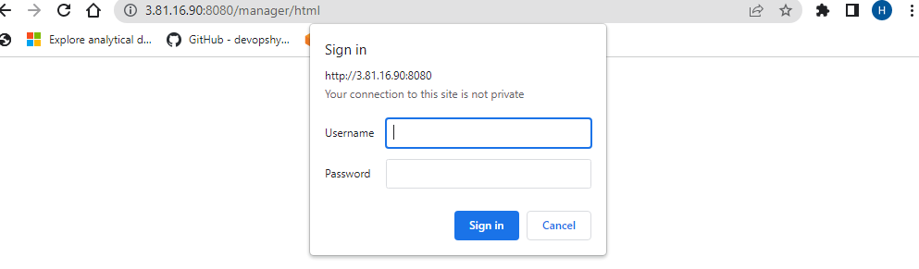

OUTPUTS
->deploy to Dev OUTPUT
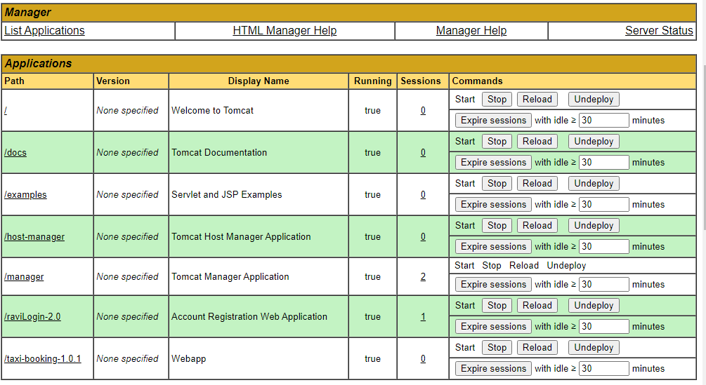

->Deploy to the test
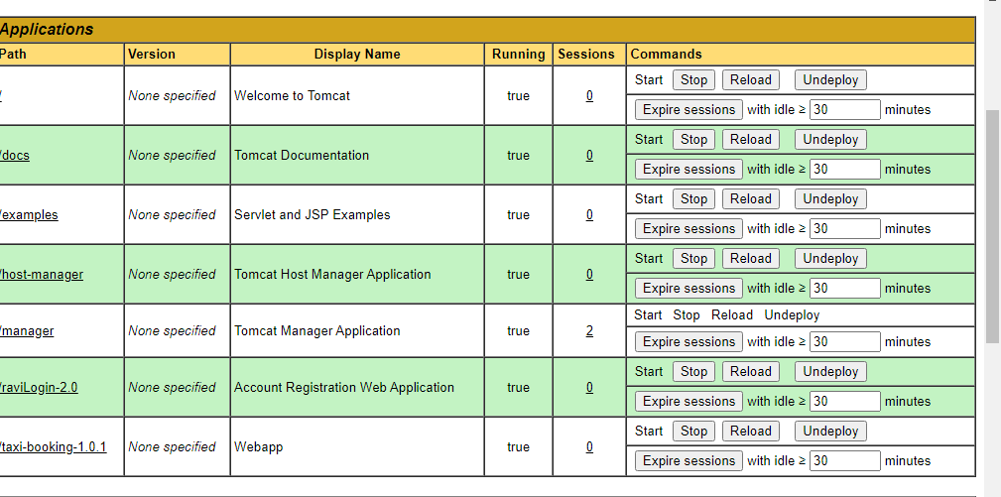
->Deploy to prod
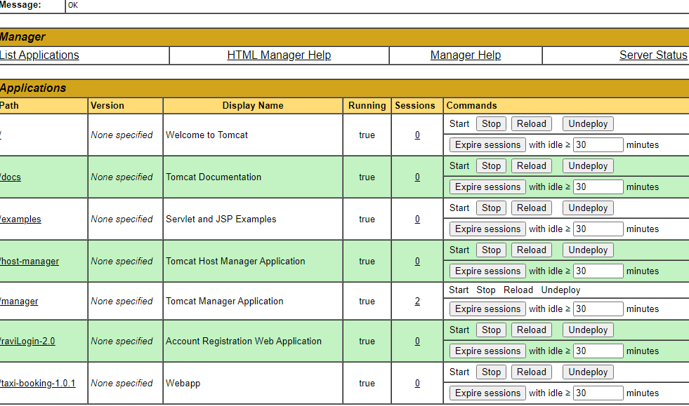

->Deplot to pre-prod
